

**Spring Boot – ThymeLeaf:**

* Thymeleaf is a Java template engine.
* It’s an opensource project and we can get more details about thymeleaf on <https://www.thymeleaf.org/>
* Commonly used to generate the HTML views for webapps
* However, it is a general-purpose templating engine
* Can use Thymeleaf outside of web apps.

It’s a separate project unrelated to spring.io, and we can create Java apps with Thymeleaf with no need of Spring.

**What is thymeleaf?**

It Can be a HTML page with some Thymeleaf expressions.

Include dynamic content from Thymeleaf expressions, and they can access Java code, objects, Spring beans and so on.

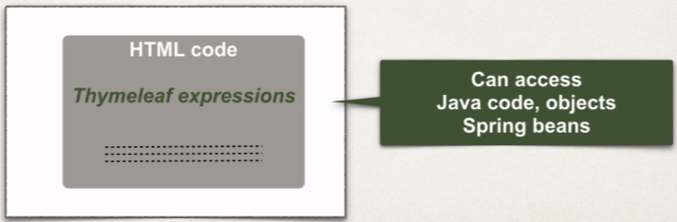

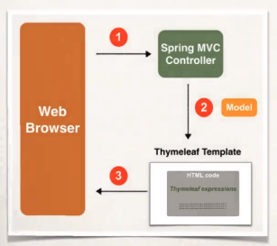**Where is Thymeleaf template processed?**

In web app, thymeleaf is processed on server. So, the results included in HTML returned to the browser.

And It’s very similar to the JSP.

**Thymeleaf vs JSP**

* **Yes,** Thymeleaf is similar to JSP.
* Can be used for web view templates

**One key difference**

* JSP can only be used in a web environment.
* Thymeleaf can be used in web OR non-web environments.

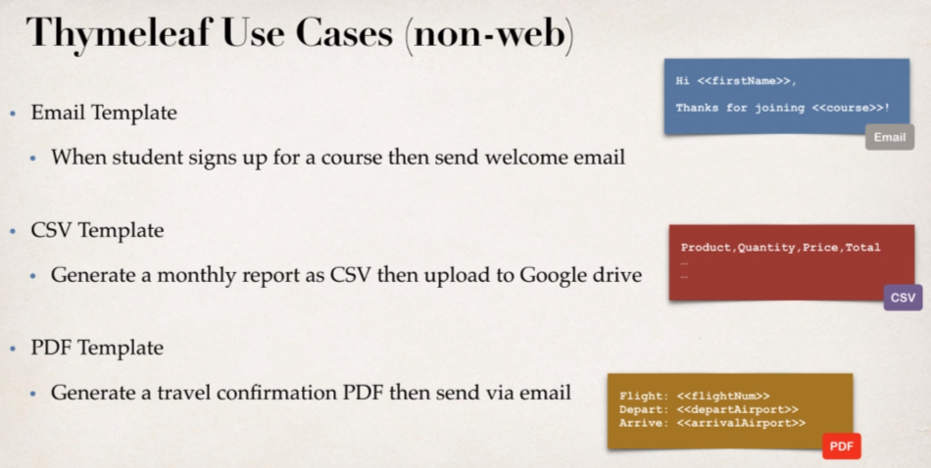

**FAQs: Should I use JSP or Thymeleaf?**

* Depends on your project requirements.
* If we only need web views then we can use either one of them.
* But if we need a general-purpose template engine (non-web) use thymeleaf.

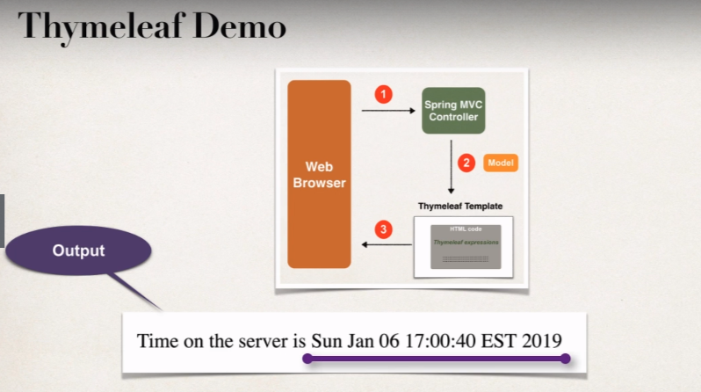**Development Process:**

1. Add Thymeleaf to Maven POM file.
2. Develop Spring MVC Controller.
3. Create Thymeleaf template.

[**Java Project Link**](https://github.com/000GEV744/Spring-Git/tree/main/thymeleafdemo)

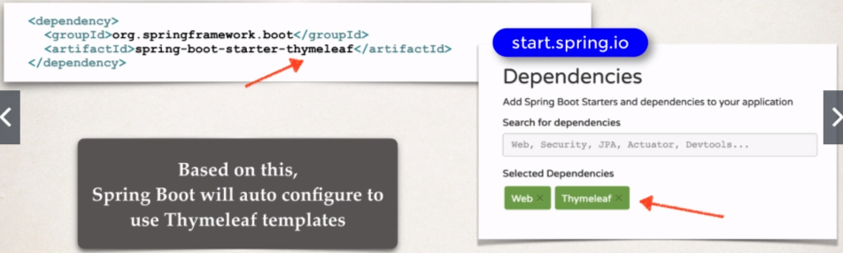**Step 1:**

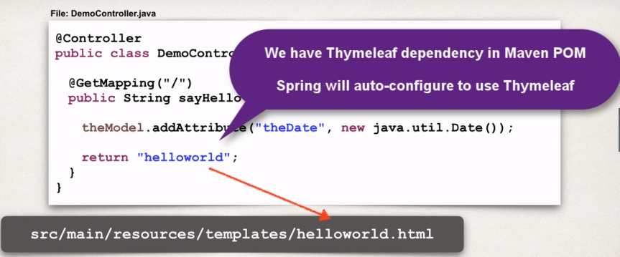**Step 2:**

**Where to Place Thymeleaf template?**

* In spring boot, your thymeleaf template files go in

**src/main/resources/templates**

* For web apps, thymeleaf templates have a **.html** extension.

**Step 3:**

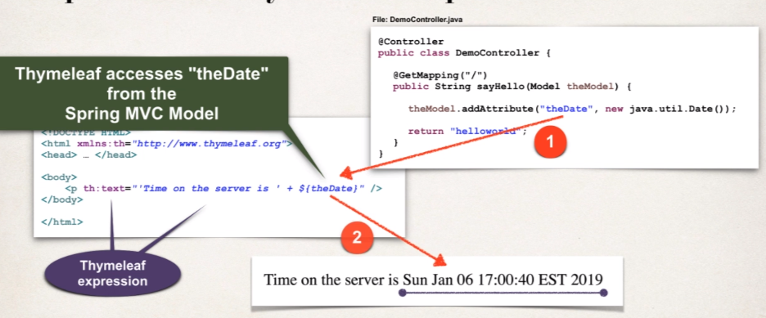

**Additional Features:**

1. **Looping and conditionals**
2. **CSS and JavaScript integration**
3. **Template layouts and fragments**

**CSS And Thymeleaf**

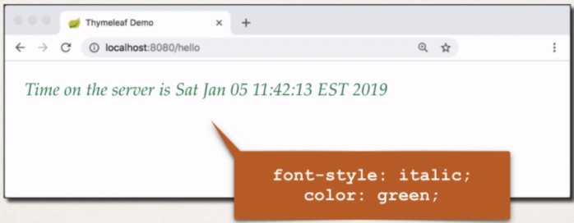Now, we want to add some styling to our view page.

**Using CSS with Thymeleaf templates:**

You have the option of using

* Local CSS files as part of your project.
* Referencing remote CSS files

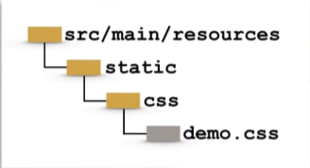**Development Process:**

*Step 1:* Spring Boot will look for static resources in the directory.

**src/main/resources/static**

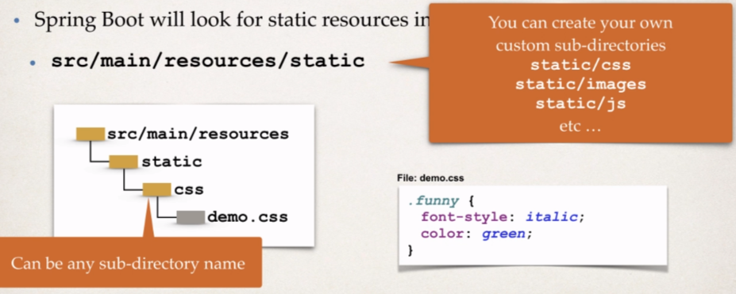

*Step 2:* Reference CSS in Thymeleaf template

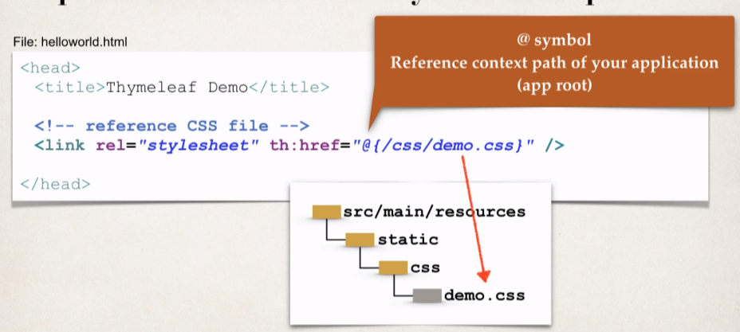

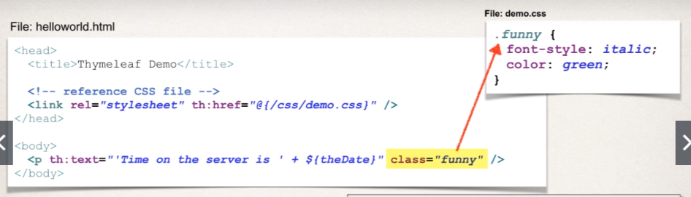*Step 3:* Apply CSS:

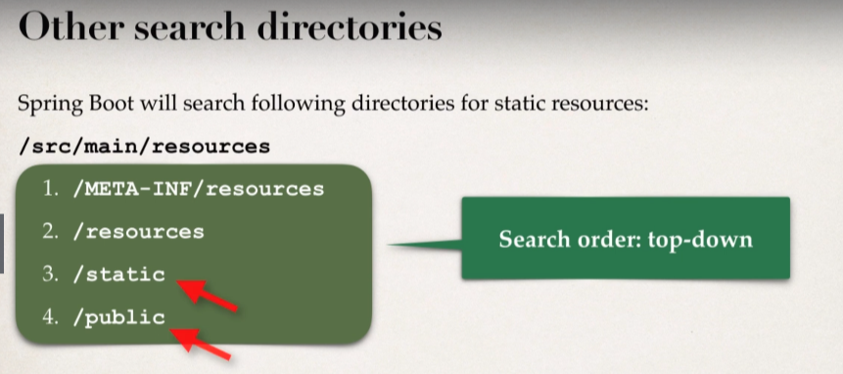

* **3rd party CSS Libraries – Bootstrap**
* Local Installation.
* Download Bootstrap file(s) and add to **/static/css** directory.

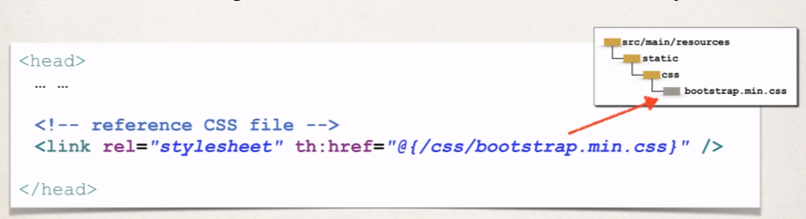

* We can access CSS files remotely onto the internet.

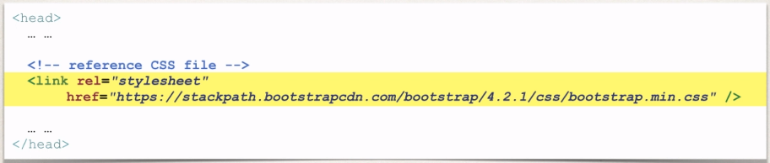So, we can simply give href location to the css file where it is stored on the internet.

* 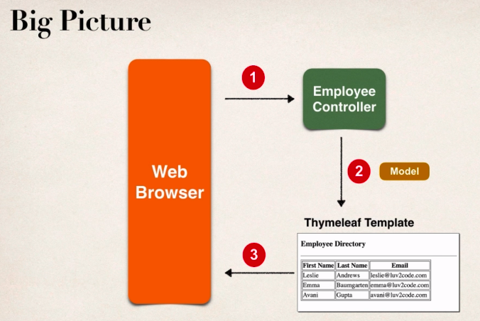**Spring Boot thymeleaf-Build HTML table:** [Java Project Link](https://github.com/000GEV744/Spring-Git/tree/main/32-thymeleafdemo-employees-list)

**Development Process:**

1. Create Employee class:
2. Create Employee Controller

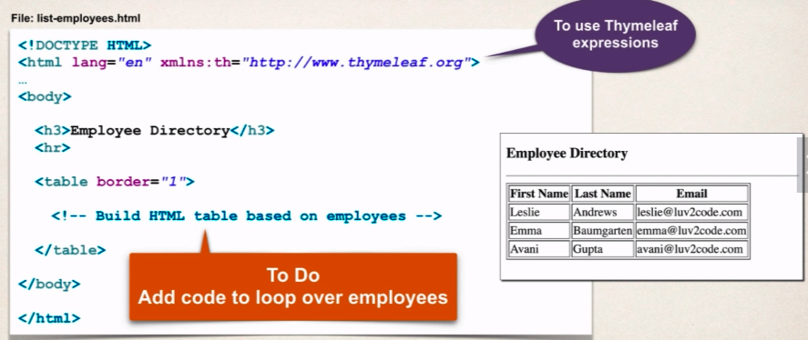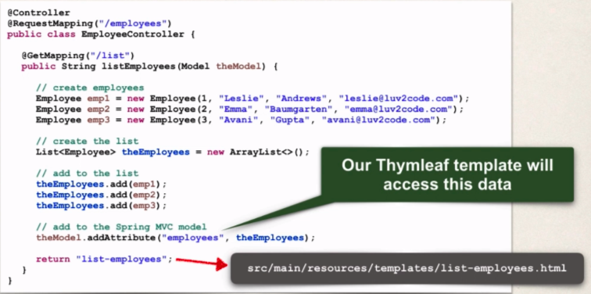

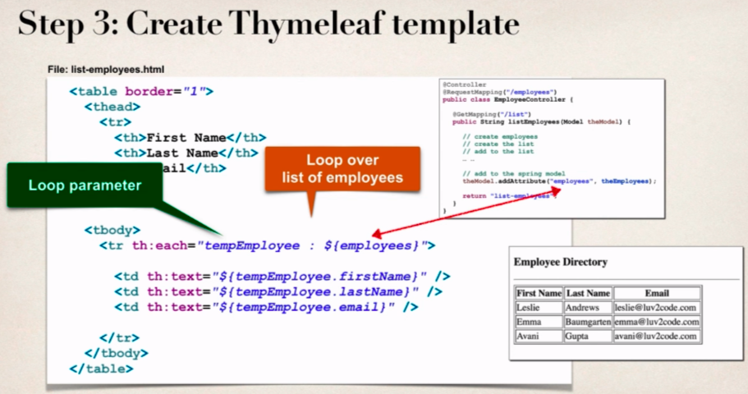

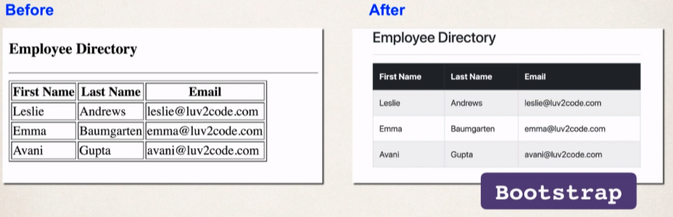Let’s add the CSS:

**Development process:**

1. 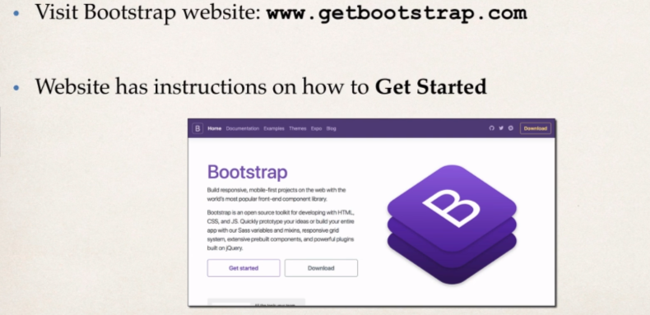Get links for remote Bootstrap files.

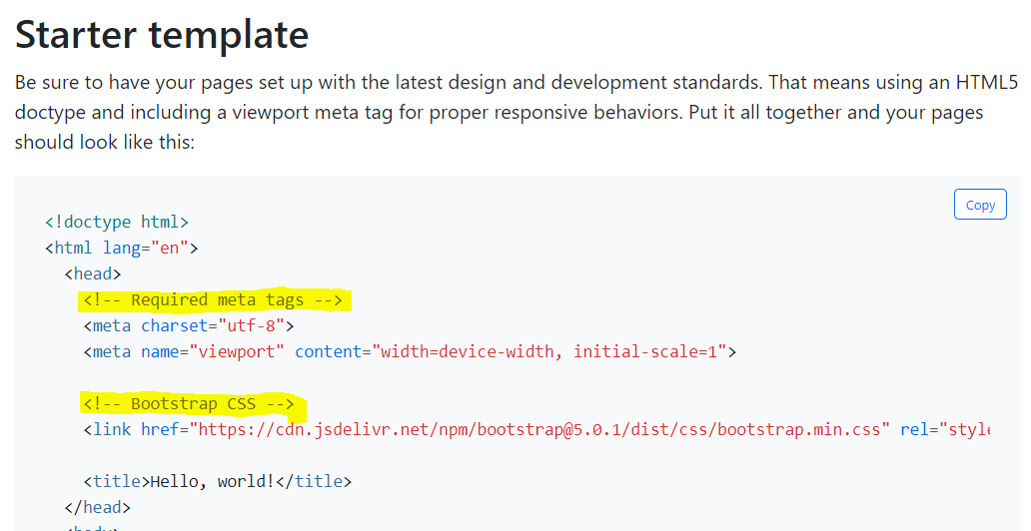

**Copy-Paste the highlighted texts into the html header section.**

1. Add links in Thymeleaf template

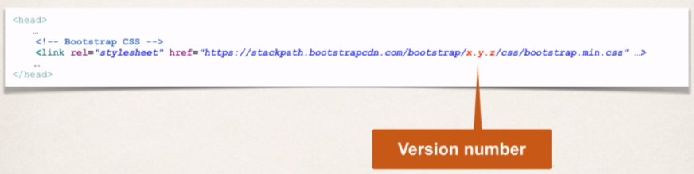

Version no. will vary depending upon the current bootstrap release.

1. 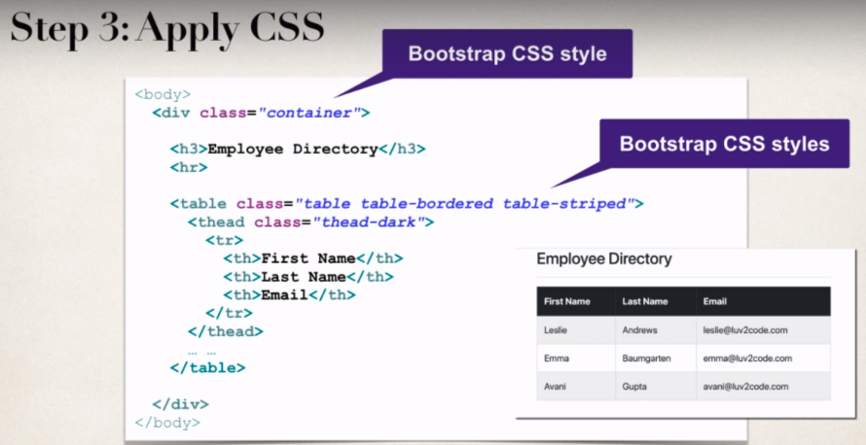Apply Bootstrap CSS styles.

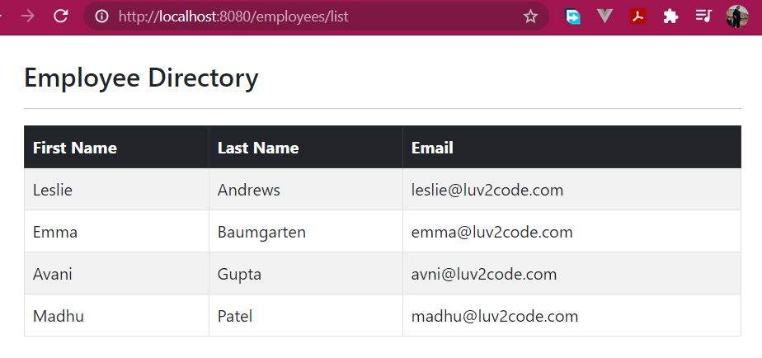

* 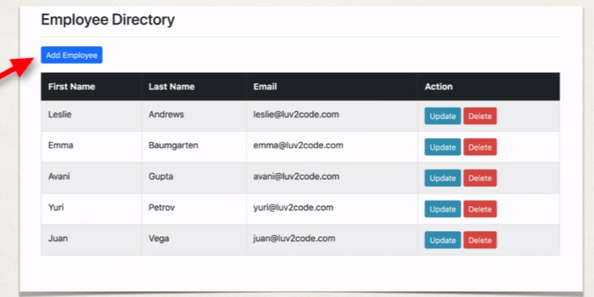**Real-time Project** [Java Project Link](https://github.com/000GEV744/Spring-Git/tree/main/33-thymeleafdemo-employees-list-db)

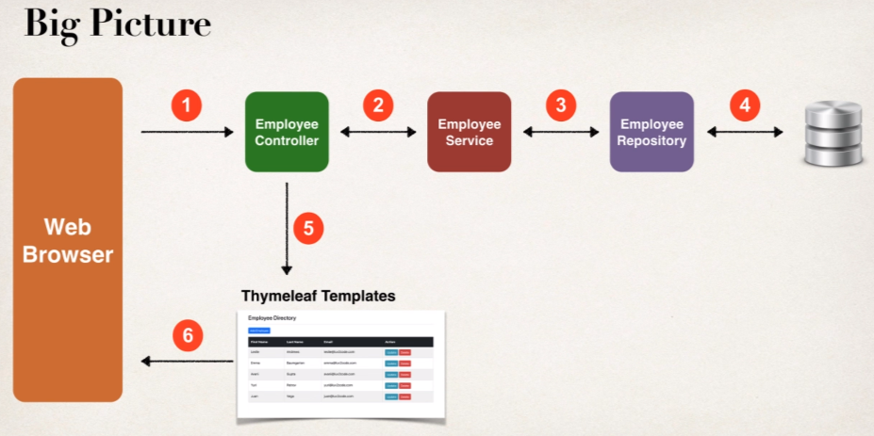

On hitting the URL: <http://localhost:8080/> we want to redirect to <http://localhost:8080/employees/list>

For that, we will create **index.html** page inside our **src/main/resources/static/**

And following code will be written inside the index.html page to redirect to <http://localhost:8080/employees/list>

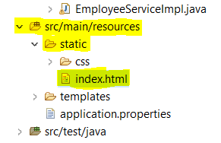**File:** **src/main/resources/static/index.html**

<meta http-equiv=*"refresh"* content=*"0; URL='employees/list'"*>

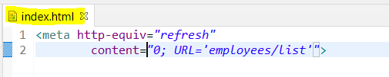

* **Add Employee**

1. New Add Employee button for list-employees.html

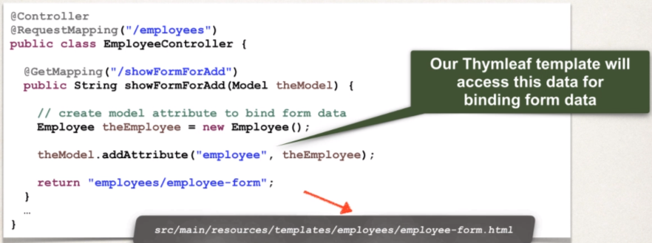

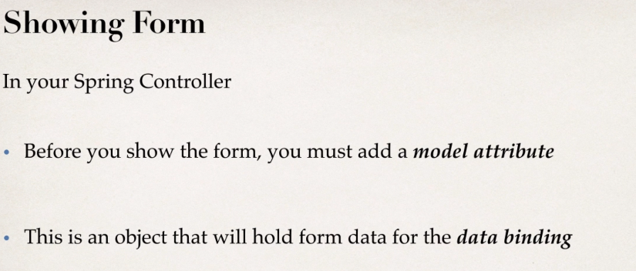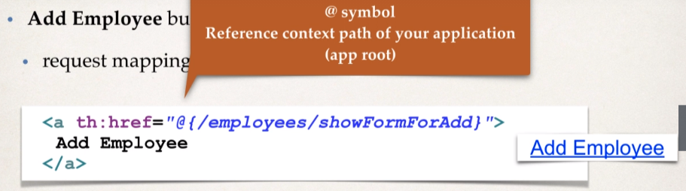

1. Create HTML form for new Employee.

**Thymeleaf and Spring MVC DATA Binding:**

* Thymeleaf has special expressions for binding Spring MVC form data
* Automatically setting/retrieving data from a Java Object.
* So, these thymeleaf expressions can help you to build the HTML form.

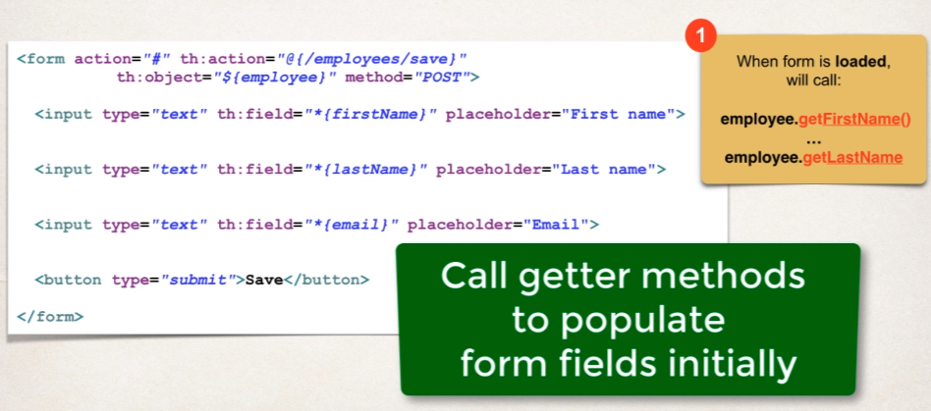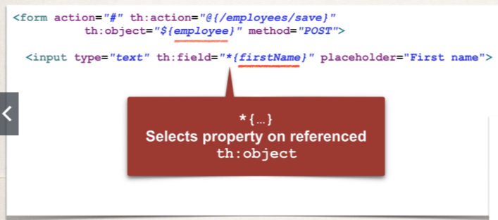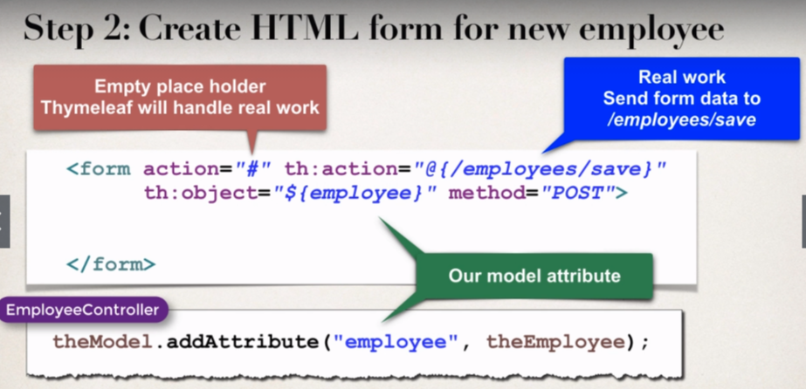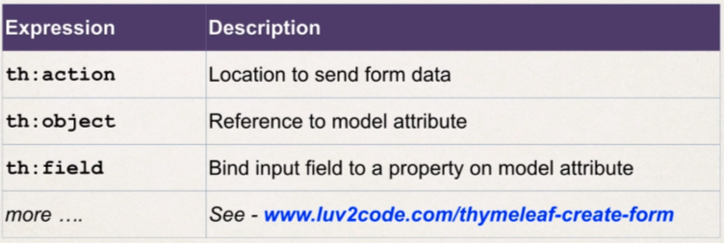

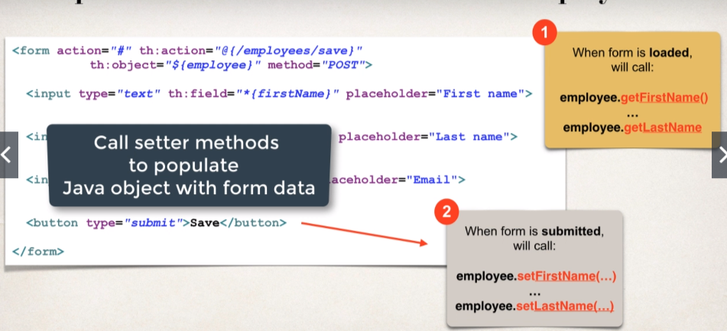

1. Process form data to save employee

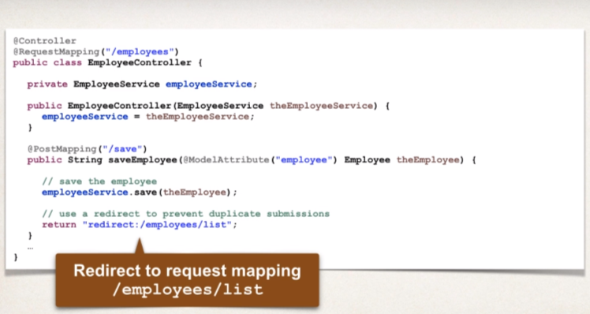

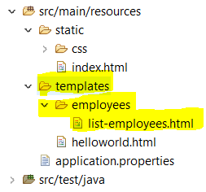**Note:** We will keep all the HTML(s) related to employee into one folder.

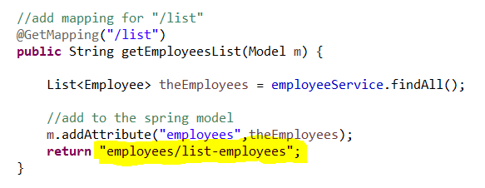So, accordingly we need to update in our controller class so that it can find the appropriate view page.

We want to get the list of employees from the database which must be sorted on to the basis of Last Name then we will add an abstract method into the **EmployeeRepository** Interface:

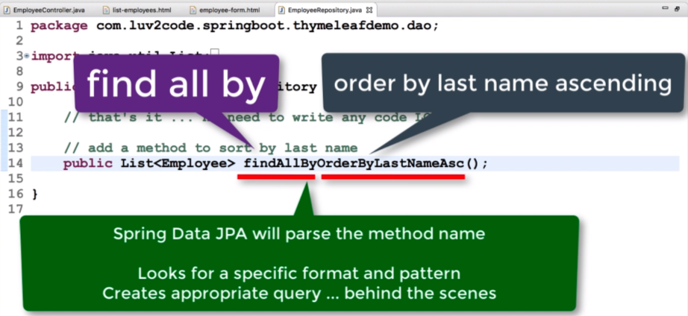

**Update the Employee**

1. 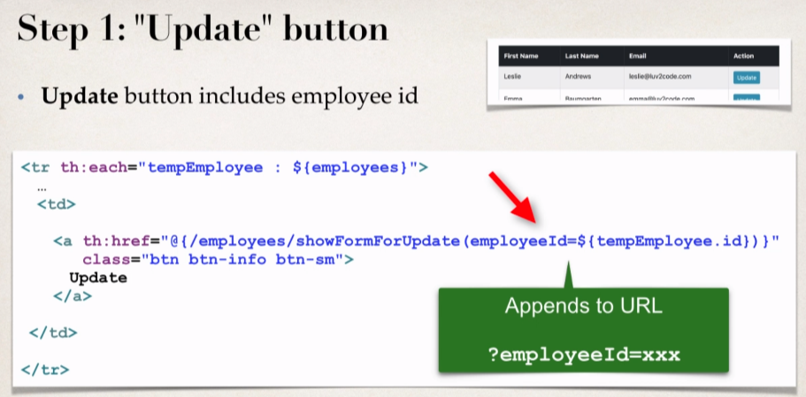“Update” button.
2. 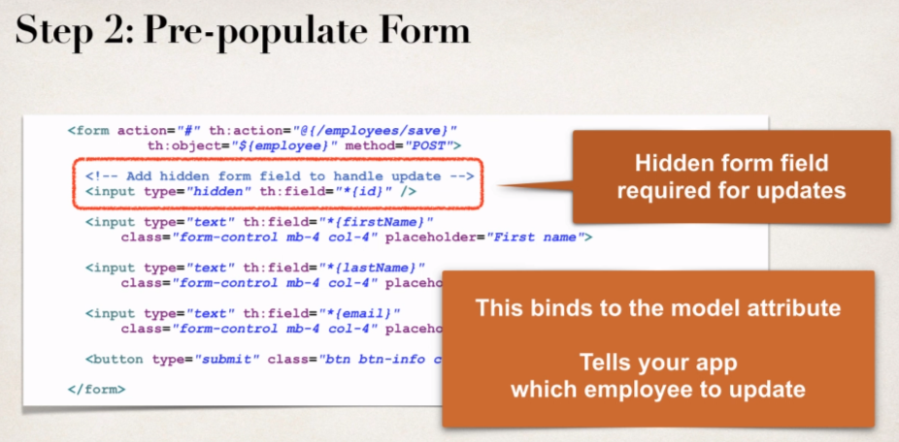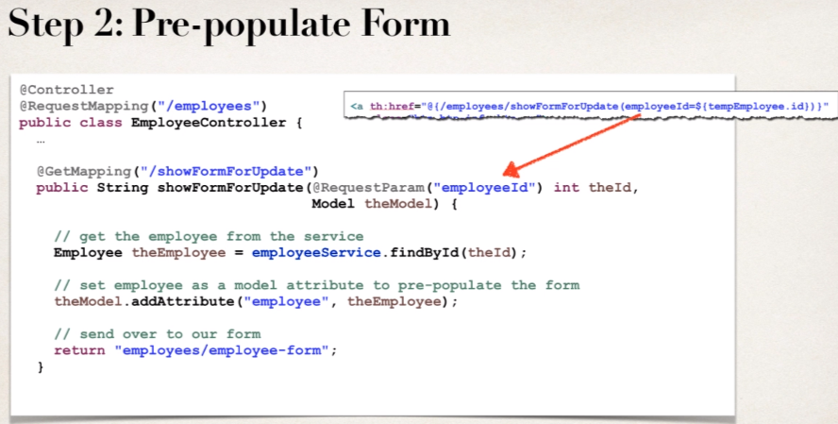Pre-populate the form.
3. 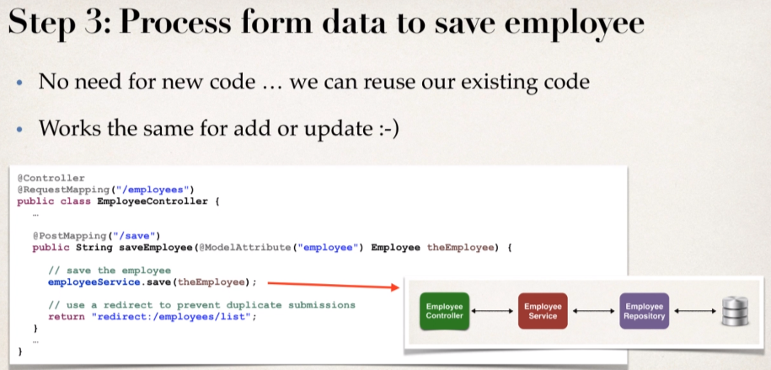Process form data.

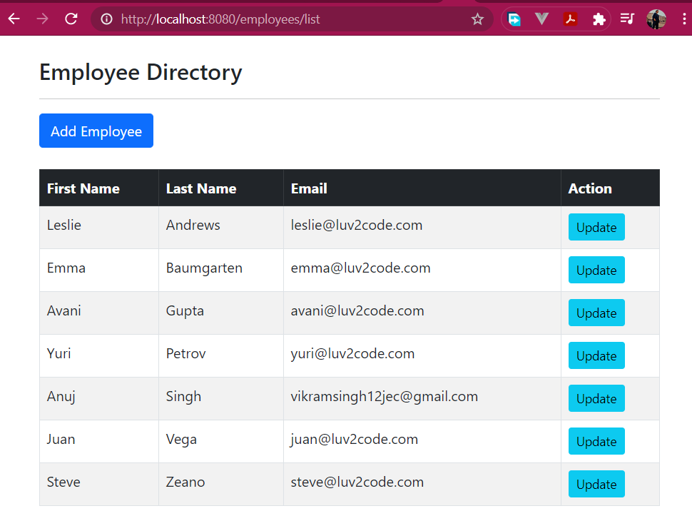

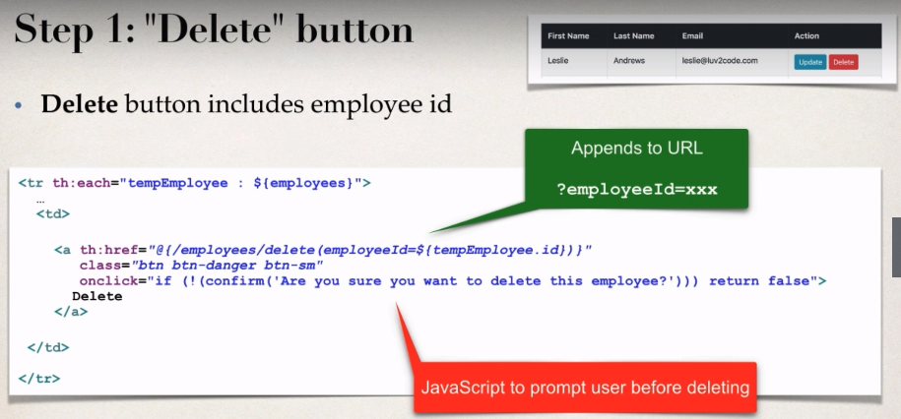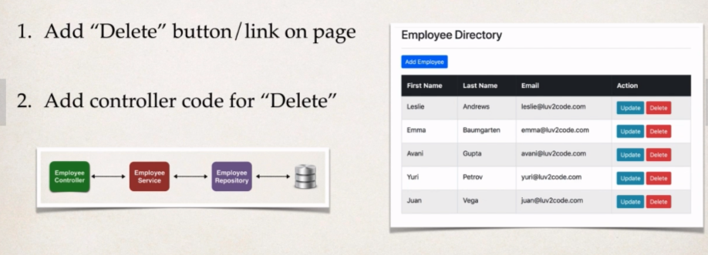**Delete Employee**

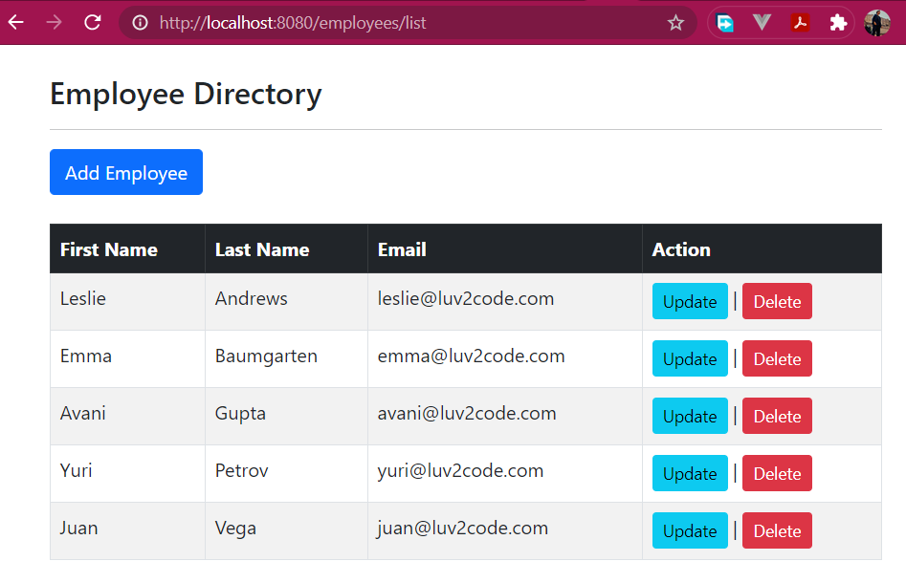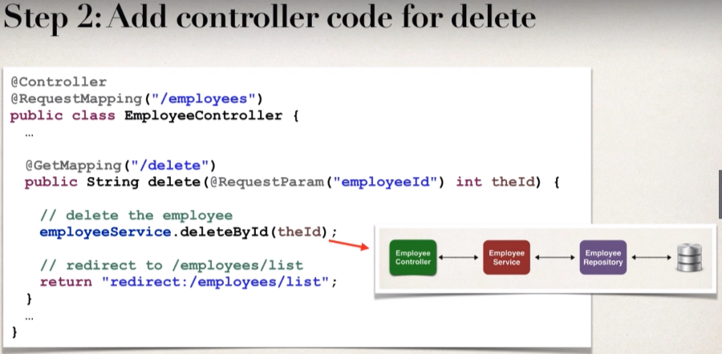

Link to this project having registration page as well: [Link](https://github.com/000GEV744/Spring-Git/tree/main/bonus-code-spring-security-user-registration-custom-user-details-thymeleaf-spring-boot)

Link to this project having login and logout support (in-memory): [Link](https://github.com/000GEV744/Spring-Git/tree/main/bonus-thymeleafdemo-employees-security-with-in-memory-authentication)

Link to this project having login and logout support

(JDBC authentication with encrypted password): [Link](https://github.com/000GEV744/Spring-Git/tree/main/bonus-thymeleafdemo-employees-security-with-jdbc-authentication)

**FAQ: How to Configure Multiple Datasources in Spring and Spring Boot**

Answer

Here are two examples, one using regular Spring and another using Spring Boot

**1. Multiple Data Sources in Spring**

This project shows how to configure multiple datasources in Spring. The project makes use of all Java configuration with Spring. The project is based on Maven.

In this project, we connect to two different databases: web_customer_tracker and employee_directory

1. SQL Scripts

The SQL scripts are located in the directory:

sql-scripts

- customer.sql: creates the database schema "web_customer_tracker", also adds sample data

- employee.sql: creates the database schema "employee_directory", also adds sample data

You will need to run these scripts accordingly.

2. Data source configuration

The project includes two configuration files to the data source configuration. The files are in the directory:

src/main/resources

- customer-persistence-mysql.properties

- employee-persistence-mysql.properties

3. Spring All Java Configuration

Directory: src/main/java/com/luv2code/demo/datasources/config

View the file: DemoAppConfig.java

This file defines two datasources using the @Bean annotation. One datasource for customerDataSource and another for employeeDataSource. The datasources also need their respective session factories and transaction managers

4. Java DAO code

The project includes DAOs for Customer and Employee. Make note of the @Autowired for the respective session factory. Also make note of the use of @Transactional with the name the of appropriate bean.

5. Controller code

The controller makes use of the customer and employee DAOs. The data is placed in the model.

6. View page

File: display-results.jsp

This JSP page displays the results. It has an HTML table for Employee data and another HTML table for Customer data.

--------

**2. Multiple Data Sources in Spring Boot**

Creating a custom data source using @Configuration and DataSourceBuilder

* 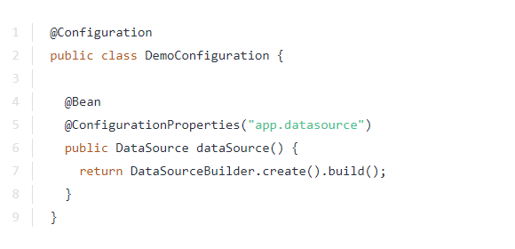Create configuration class. Specify the prefix of your properties

1. Add these to application.properties. Note the prefix of properties. Also note: "jdbc-url" … not just “url"
2. #
3. # JDBC properties
4. #
5. app.datasource.jdbc-url=jdbc:mysql://localhost:3306/employee_directory?useSSL=false&serverTimezone=UTC
6. app.datasource.username=springstudent
7. app.datasource.password=springstudent

Now if you want more datasources … just use more @Beans

1. @Bean
2. @ConfigurationProperties(“alpha.datasource")
3. public DataSource alphaDataSource() {
4. return DataSourceBuilder.create().build();
5. }
6. @Bean
7. @ConfigurationProperties(“bravo.datasource")
8. public DataSource betaDataSource() {
9. return DataSourceBuilder.create().build();
10. }

In application.properties

1. alpha.datasource.jdbc-url=jdbc:mysql://localhost:3306/employee_directory?useSSL=false&serverTimezone=UTC
2. alpha.datasource.username=springstudent
3. alpha.datasource.password=springstudent
5. beta.datasource.jdbc-url=jdbc:mysql://localhost:3306/demo?useSSL=false&serverTimezone=UTC
6. beta.datasource.username=foo
7. beta.datasource.password=bar

Resources for this lecture: [LINK](https://github.com/000GEV744/Spring-Git/tree/main/bonus-code-multiple-jdbc-datasources-regular-spring)

FAQ: Spring Student Questions

**Congrats for finishing the course.**

A frequently asked question is "Where to go from here?" A lot of developers want to further their knowledge by learning advanced Spring topics and practicing projects.

I've compiled a list of resources that you can use to get more information on Spring advanced features. Enjoy!

**Spring Boot and Angular**

- [https://github.com/dsyer/spring-boot-angular](http://websystique.com/springmvc/spring-4-mvc-angularjs-crud-application-using-ngresource/)

**Spring MVC and File Upload**

-<https://spring.io/guides/gs/uploading-files/>

**Spring RESTful web services**

- <https://spring.io/guides/gs/rest-service/>

**Spring Security for Web Apps**

- <https://spring.io/guides/gs/securing-web/>

**Spring and Facebook**

- <https://spring.io/guides/gs/accessing-facebook/>

**Spring and Twitter**

- https://spring.io/guides/gs/accessing-twitter/

--- **Build a Basic CRUD App with Angular and Spring Boot**

<https://developer.okta.com/blog/2017/12/04/basic-crud-angular-and-spring-boot>

=====

**FAQ: I would like to see examples of real-world projects that use Spring**

**Answer:**

Here are some sample Spring projects you can look at.

They are of moderate size complexity

**Project Sagan**

This is a real-world app that powers the Spring.io website. It is in production and used by thousands of users each day.

You can get information about the project and get source code here: - <https://github.com/spring-io/sagan/wiki>

         ---

**Spring Petstore Example**

This is an example project for the classic PetClinic / PetStore example. <https://github.com/spring-projects/spring-petclinic>

---

**E-Commerce Product - Broadleaf**

<https://www.broadleafcommerce.com/>

The Broadleaf product is based on Spring and Hibernate. You can get details on their framework and source code at the link below

<https://www.broadleafcommerce.com/framework>

---

**OpenSource Projects Using Spring**

Access real-world projects that make use of Spring code - <http://www.programcreek.com/2012/08/open-source-projects-that-use-spring-framework/>

---

Finally there are some other instructors here on Udemy that created courses on Spring ecommerce, angular etc. Be sure to check the reviews  
and perform your own research on those courses. I am not involved in any of those other courses. I just wanted to pass information along :-)

=====

**FAQ: How to Host my Java apps Online?**

---

Here's a free guide that walks you through the steps:

**The Ultimate Guide to Hosting a Java Web App with Amazon Web Services (AWS)**<http://coderscampus.com/ultimate-guide-hosting-java-web-app-amazon-web-services-aws/>

=====

**Student Question**I want a solution for hiding customer id in URL. Maybe,change request from GET to POST?

-----

**Solution**

In the files below, look for modified code. Simply search for the text "luv2code: UPDATES".

Here's the basic approach.

For the links, change the table to use forms. There is a form for each row of data. The form would be setup to POST the data. Each row would have a unique button with the ID embedded. Apply special CSS to make the Submit button look like a hypertext link.

The controller request mappings will now support @PostMapping. This is for /showFormForUpdate and /delete

---

**Notes about the solution.**

Using the POST method does not add security. It simply "hides" the request data. But any web user can still easily see the data. All they have to do is use Chrome Dev Tools or FireFox Firebug. So, using POST is only giving you "security by obscurity" which is weak if you have highly sensitive data.

If you have highly sensitive data then you should use SSL encryption on your server and make use of Spring Security to protect sensitve web URLs in your app.

---

Having the customer ID in the URL is not a problem. The GET approach is a standard practice that is used in the industry. However the solution was provided based on student's request.

In our example, the ID is for customers ... but this could easily be a product ID. The important thing is the customer ID is not sensitive data.

If you check the major ecommerce sites like Amazon or Best Buy, the product ID is heavily used in the URL.

The URLs below are live URLs on production ecommerce systems that use product ID in the URL.

Amazon  
- https://www.amazon.com/dp/B01DFKC2SO

BestBuy  
- http://www.bestbuy.com/site/amazon-echo-dot/5578864.p?skuId=5578864

---

**Solution Source Code**

- <https://gist.github.com/darbyluv2code/df856411a3e0c926a4654660045acda4>

======

**FAQ: Which more secure? GET or POST?**

Note, simply using the POST method does not add secure encryption. The data is still sent in the clear without any protection or encryption.

See this link:

**Is either GET or POST more secure than the other?**

<https://stackoverflow.com/questions/198462/is-either-get-or-post-more-secure-than-the-other>

---

You can use SSL for enterprise-grade network security and encryption.

Here's a tutorial on Tomcat SSL: <https://www.mulesoft.com/tcat/tomcat-ssl>

**Deploying Spring Boot WAR file with JSP to Tomcat**

**Deploy Spring Boot apps with JSP to Tomcat**

You can deploy a Spring Boot application using JSP to Tomcat. In this scenario, we will create a WAR file and deploy the WAR to the Tomcat server running externally. This is known as a traditional deployment.

**High-level steps**

1. Update main Spring Boot application

2. Update Maven POM file

3. Update application.properties

4. Move JSP view files to WEB-INF/view

5. Create WAR file

6. Deploy to Tomcat

**Spring Boot Reference Manual**

For full details on this process, see the [Spring Boot Reference Manual: Section 92.1 Creating a Deployable WAR file](https://docs.spring.io/spring-boot/docs/current/reference/htmlsingle/#howto-create-a-deployable-war-file)

**Working Example**

I have a full working project. You can download this app and perform test deployments to Tomcat

Download: [deploy-spring-boot-and-jsp-on-tomcat.zip](https://drive.google.com/file/d/1jgjQ1DCpowDJxlFje-dS6rjoQKRcYtCe/)

This app is a very simple helloworld example that exposes a "/test" request mapping

1. package org.demo.bootjsp.controller;
3. import org.springframework.stereotype.Controller;
4. import org.springframework.web.bind.annotation.RequestMapping;
6. @Controller
7. public class HelloWorldController {
9. @RequestMapping("/test")
10. public String sayHello() {
11. return "hello";
12. }
14. }

and a simple JSP page: hello.jsp

1. <html><body>
3. <p>
4. Hello World! Time is <%= new java.util.Date() %>
5. </p>
7. <p>
8. We are running on <%= application.getServerInfo() %>!!!
9. </p>
11. </body></html>

----

**Detailed steps**

**1. Update main Spring Boot application**

In your main Spring Boot application, you need to

a. extend the SpringBootServletInitializer

b. override the configure(...) method

Your code should look like this

1. package org.demo.bootjsp;
3. import org.springframework.boot.SpringApplication;
4. import org.springframework.boot.autoconfigure.SpringBootApplication;
5. import org.springframework.boot.builder.SpringApplicationBuilder;
6. import org.springframework.boot.web.servlet.support.SpringBootServletInitializer;
8. @SpringBootApplication
9. public class DemowebApplication extends SpringBootServletInitializer {
11. @Override
12. protected SpringApplicationBuilder configure(SpringApplicationBuilder application) {
13. return application.sources(DemowebApplication.class);
14. }
16. public static void main(String[] args) {
17. SpringApplication.run(DemowebApplication.class, args);
18. }
20. }

**2. Update Maven POM file**

Update your POM.xml to use WAR packaging

<packaging>war</packaging>

In POM.xml, add dependency to be able to compile JSPs

1. <dependency>
2. <groupId>org.apache.tomcat.embed</groupId>
3. <artifactId>tomcat-embed-jasper</artifactId>
4. </dependency>

Make sure the Tomcat embedded does not interfere with external Tomcat server

1. <dependency>
2. <groupId>org.springframework.boot</groupId>
3. <artifactId>spring-boot-starter-tomcat</artifactId>
4. <scope>provided</scope>
5. </dependency>

**3. Update application.properties**

In your application.properties file, you should have

1. spring.mvc.view.prefix=/WEB-INF/view/
2. spring.mvc.view.suffix=.jsp

**4. Move JSP view files to WEB-INF/view**

Move your JSP view pages should to src/main/webapp/WEB-INF/view

**5. Create WAR file**

Create the WAR file with the command: mvn clean package

This will generate a WAR file in your project directory:  **target/bootjspdemo.war**

6. In Eclipse, stop all servers you may have running

7. Outside of Eclipse, run your Tomcat server

8. Copy your WAR file to the **<<tomcat-install-dir>>/webapps** directory

Wait for about 15-30 seconds for Tomcat to deploy your app. You will know your app is deployed when you see a new folder created based on your WAR file name. In our example, you will see a new directory named: **bootjspdemo**

9. In a web browser, access your app at: http://localhost:8080/bootjspdemo/test

Replace <<bootjspdemo>> with the name of your WAR file if you are using a different app

If everything is successful, you will see your application's web page.

Congratulations! You deployed a Spring Boot WAR file with JSP on to a Tomcat server :-)